“Київський фаховий коледж зв’язку”

Циклова комісія Комп’ютерної інженерії

**ЗВІТ ПО ВИКОНАННЮ**

**ЛАБОРАТОРНОЇ РОБОТИ №6**

з дисципліни: «Операційні системи»

**Тема: “Команди Linux для архівування та стиснення даних. Робота з текстом”**

Виконали студенти

Групи КСМ – 13а

Команда Better Call Chekh:

Бродзінський Є.В.

Кравченко Т.І.

Тунда Р.О.

Перевірив викладач

Сушанова В.С.

Київ 2023

**Мета роботи:**

**1. Отримання практичних навиків роботи з командною оболонкою Bash.**

**2. Знайомство з базовими командами для архівування та стиснення даних.**

**3. Знайомство з базовими діями при роботі з текстом у терміналі.**

**Матеріальне забезпечення занять**

**1. ЕОМ типу IBM PC.**

**2. ОС сімейства Windows (Windows 7).**

**3. Віртуальна машина – Virtual Box (Oracle).**

**4. Операційна система GNU/Linux – CentOS.**

**5. Сайт мережевої академії Cisco netacad.com та його онлайн курси по Linux**

**Завдання для попередньої підготовки**

***Готував матеріал студент Бродзінський Є.В.***

1. Прочитайте короткі теоретичні відомості до лабораторної роботи та зробіть невеликий словник базових англійських термінів з питань призначення команд та їх параметрів.

|  |  |
| --- | --- |
| **Термін англійською** | **Термін українською** |
| Compression | Стиснення |
| Lossy Compression | Втратне стиснення |
| Lossless Compression | Безвтратне стиснення |
| gzip Compression | Стиснення gzip |
| bzip2 Compression | Стиснення bzip2 |
| xz Compression | Стиснення xz |
| tar | Архіватор tar |
| -z, -j, -J | Параметри команд |
| -c | Параметр команди tar |
| -t -x | Параметр команди tar |

2. Вивчіть матеріали онлайн-курсу академії Cisco “NDG Linux Essentials”:

- Chapter 09 - Archiving and Compression

- Chapter 10 - Working With Text

3. Пройдіть тестування у курсі NDG Linux Essentials за такими темами:

- Chapter 09 Exam

- Midterm Exam (Modules 1 - 9) буде окреме завдання в гугл-класі

- Chapter 10 Exam

4. На базі розглянутого матеріалу дайте відповіді на наступні питання:

4.1. Яке призначення команд tar, xz, zip, bzip, gzip? Зробіть короткий опис кожної команди та виділіть їх основні параметри. Яким чином їх можна встановити.

1)tar

Purpose:

This command is used to create, unzip, and manage file and directory archives.

Main parameters:

-c: Create a new archive.

-t: Display the list of files in the already created archive.

-x: Unzip the archive and restore the file and directory structure.

Installation:

The "tar" command is a standard installation, meaning no additional installation is required

2)xz

Purpose:

The "xz" command is used to compress and decompress files using the LZMA2 algorithm.

Main parameters:

-c: Compress the contents of the file and output it to standard output.

-d: Unzip compressed file.

Installation: "xz" can be installed using the yum package manager: sudo yum install xz

3)zip

Purpose:

This command is used to compress and archive files in ZIP format.

Main parameters:

-r: Create archive recursively, including all files and subdirectories.

-u: Update the archive by adding new files to the existing archive.

Installation:

The "zip" command is usually already installed, but if we don't have it installed, we can install it using the yum package manager: sudo yum install zip.

4)bzip

Purpose:

The "bzip" command is used to compress and decompress files.

Main parameters:

-c: Compress the contents of the file and output it to standard output.

-d: Unzip compressed file.

Installation:

The "bzip" command is already installed and does not require additional installation.

5)gzip

Purpose:

The "gzip" command is used to compress and decompress files using the DEFLATE algorithm. It compresses files and gives them the extension ".gz"

Main parameters:

-c: Compress the contents of the file and output it to standard output.

-d: Unzip compressed file.

Installation:

The "gzip" command is already installed and does not require additional installation.

***Готував матеріал студент Тунда Р.***

4.2. Наведіть три приклади реалізації архівування та стискання даних різними командами.

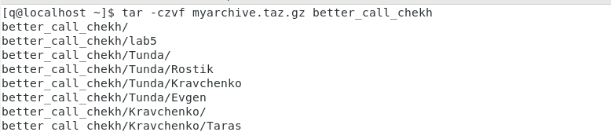

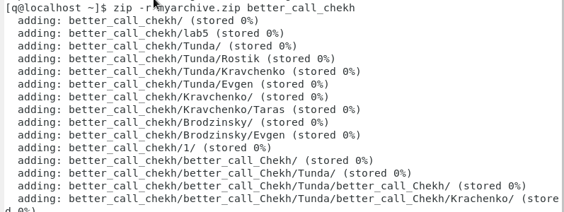

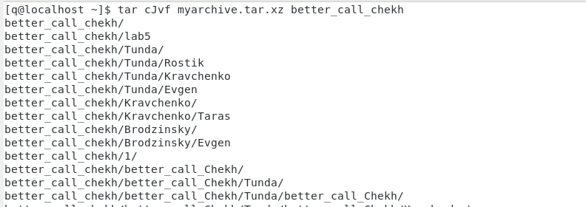

***Готував матеріал студент Бродзінський Є.В.***

4.3. Яке призначення команд cat, less, more, head and tail? Зробіть короткий опис кожної команди та виділіть їх основні параметри. Яким чином їх можна встановити

1)cat

Purpose:

The "cat" command is used to output the contents of a text file to the standard output (screen).

Main parameters:

filename: Print the contents of the given file.

> new_file: Redirect content to a new file

2)less

Purpose:

"less" is used to view large text files page by page with the ability to scroll forward and backward.

Main parameters:

less file: Open the file file for viewing.

While viewing, use the "Space" key to scroll forward and the "B" key to scroll backward.

3)more

Purpose:

"more" is used for page-by-page viewing of text files.

Main parameters:

more file: Open the file file for viewing.

While viewing, use the "Space" key to scroll forward and the "Q" key to exit.

4)head

Purpose:

"head" outputs the first few lines of a text file to standard output.

Main parameters:

head file: Print the first 10 lines of the file file.

head -n 20 file: Print the first 20 lines of the file file.

6)tail

Purpose:

"tail" outputs the last few lines of a text file to standard output.

Main parameters:

tail file: Print the last 10 lines of the file file.

tail -n 15 file: Print the last 15 lines of the file file.

Installation :

All these commands are already installed by default and do not require additional installation.

4.4. Поясніть принципи роботи командної оболонки з каналами, потоками та фільтрами

The command shell in Linux operating systems allows you to execute commands and process data using pipes, streams, and filters.

Principles of their work:

Channels (pipes):

Channels in CentOS are denoted by the vertical bar symbol |.

They allow you to pass the output of one command to the input of another command.

Example: command1 | command2 sends the output of command1 to the input of command2.

Channels allow you to create complex combinations of commands to process data.

Streams:

In CentOS, as in other UNIX-like systems, there are three main types of streams: standard input (stdin), standard output (stdout), and standard error (stderr).

They are used for data input and output.

All commands output data to standard output (stdout) and can accept input data from standard input (stdin).

Filters:

Filters in our case CentOS, they can be used for text data processing, filtering, transformation and aggregation.

Some common filters include grep for text searches, sed for text editing, and awk for complex calculations.

4.5. Яке призначення команди grep?

Purpose of the grep command:

1)Search for text: grep allows you to find all occurrences of a given text pattern in a specified file or output. You can search for both plain text and regular expressions.

2) Data filtering: grep can be used to filter the output and select only those lines that match a given pattern. This is especially useful when you need to process a large amount of text data and extract the information you need.

3)Working with regular expressions: grep supports regular expressions, allowing you to perform complex and flexible text searches. Regular expressions allow you to specify complex patterns to match text data.

4)Recursive search: With the -r or -R flag, you can run grep recursively to search for text in all files in a folder and its subfolders.

**Хід роботи**

1. Початкова робота в CLI-режимі в Linux ОС сімейства Linux:

1.1. Запустіть віртуальну машину VirtualBox, оберіть CentOS та запустіть її. Виконайте вхід в систему

під користувачем: CentOS, пароль для входу: reverse (якщо виконуєте ЛР у 401 ауд.) та запустіть

термінал.

1.2. Запустіть віртуальну машину Ubuntu_PC (якщо виконуєте завдання ЛР через академію netacad)

1.3. Запустіть свою операційну систему сімейства Linux (якщо працюєте на власному ПК та її

встановили) та запустіть термінал.

***Готував матеріал студент Бродзінський Є.В.***

2. Опрацюйте всі приклади команд, що представлені у лабораторних роботах курсу NDG Linux Essentials -

Lab 9: Archiving and Compression та Lab 10: Working With Text. Створіть таблицю для опису цих команд***

NDG Linux Essentials -Lab 9: Archiving and Compression

|  |  |
| --- | --- |
| Command name | Its purpose and functionality |
| mkdir mybackups | Create a new mybackups directory in your home directory user |
| tar -cvf mybackups/udev.tar | The tar command is used to combine multiple files into a single file |
| /etc/udev | In this case, the contents of the /etc/udev directory will be  saved in the udev.tar archive in the mybackups directory. The -c option  tells the tar command to create a tar file. The -v option means  &quot;verbose&quot;, which tells the tar command to demonstrate that it  does The -f option is used to specify the name of the tar file. |
| tar -cvf archive.tar files... | Creates and packages files and directories into a tar archive |
| tar -tvf archive.tar | Lists the contents of the tar archive. |
| tar -zcvf archive.tar.gz files... | Creates and compresses files and directories into a gzip archive.. |
| tar -jcvf archive.tar.bz2 files... | Creates and compresses files and directories into a bzip2 archive.. |
| tar -Jcvf archive.tar.xz files... | Creates and compresses files and directories into an xz archive. |
| zip archive.zip files... | Creates a ZIP archive from files and directories (with compression) |
| unzip -l archive.zip | Displays a list of files and directories contained in the ZIP archive. |
| unzip archive.zip | Extracts the ZIP archive, restoring files and directories. |
| gzip file | Compresses the file, replacing the original with the compressed file. |
| gunzip file.gz | Extracts a gzip-compressed file, restoring the original. |
| bzip2 file | Compresses a file using bzip2, replacing the original with the compressed file. |
| bunzip2 file.bz2 | Extracts a bzip2-compressed file, restoring the original. |
| xz file | Compresses a file using xz, replacing the original with the compressed file. |
| unxz file.xz | Extracts an xz-compressed file, restoring the original. |

NDG Linux Essentials - Lab 10: Working With Text

|  |  |
| --- | --- |
| Command name | Its purpose and functionality |
| tr A-Z a-z > myfile | Convert text from uppercase to lowercase. Changes the case of letters from uppercase to lowercase and writes the result to the file myfile. |
| cat myfile | Display the contents of the file on the screen. Displays the contents of the file myfile on the screen. |
| `cat /etc/passwd | more` Display the contents of the file in pages. |
| head /etc/passwd | Output the first 10 lines of the file. Prints the first 10 lines of the /etc/passwd file. |
| tail /etc/passwd | Output the last 10 lines of the file. Prints the last 10 lines of the /etc/passwd file. |
| head -2 /etc/passwd | Output the first two lines of the file. Prints the first two lines of the /etc/passwd file. |
| `ls /etc | tail -5` Display the last five files in the directory. |
| grep sshd passwd | Search for strings with the substring "sshd". Finds and outputs lines with the substring "sshd" in the passwd file. |
| grep '^root' passwd | Search for strings starting with "root". Finds and outputs lines starting with "root" in the passwd file. |
| grep 'sync$' passwd | Search for strings that end with "sync". Finds and outputs lines ending with "sync" in the passwd file. |
| grep '.y' passwd | Search for strings where "y" is preceded by any character. Finds and outputs lines where "y" is preceded by any character in the passwd file. |
| `egrep 'no(b | Search for strings that contain "nob" or "non". |
| `head passwd | Search for strings that contain at least one digit in the first 10 lines of the file. |
| grep -E '[0-9]{3}' passwd | Search for strings that contain a sequence of three digits. Finds and outputs lines that contain a sequence of three digits in the passwd file. |

***Готував матеріал студент Тунда Р.***

3. Ознайомтесь з командою tar та за її допомогою виконати у терміналі наступні дії:

- створити файл з розширенням .tar;

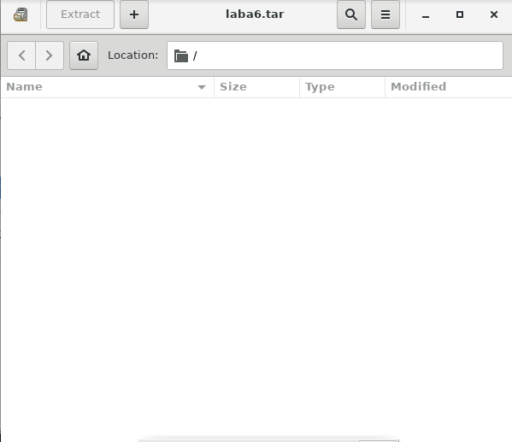

- створити файл з розширенням .tar, що складається з декількох файлів і каталогів одночасно;

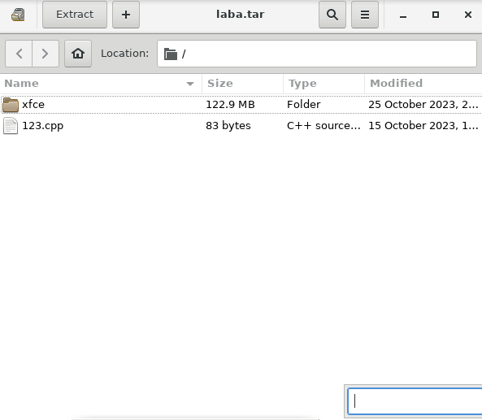

- перегляду вмісту файлу;

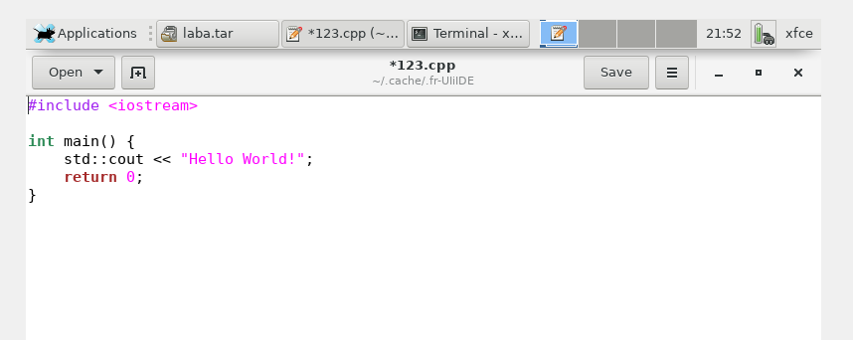

- витягти вміст файлу tar;

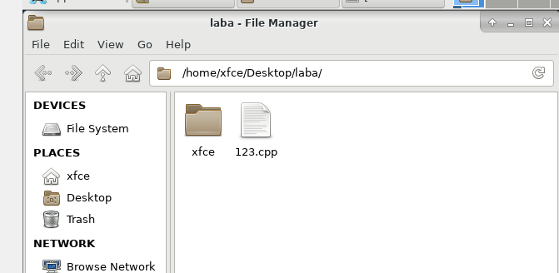

- створити архівний файл tar, стиснений за допомогою bzip;



- витягти вміст файлу tar bzip;



- створити архівний tar файл, стисненого за допомогою gzip;



- витягти вміст файлу tar gzip.



***Готував матеріал студент Бродзінський Є.В.***

4. Як буде відбуватись перенаправлення потоків виведення в bash для наступних дій з командами (позначено як cmd) та файлами (позначено як file):

|  |  |
| --- | --- |
| **Команда** | **Що виконує команда?** |
| cmd 1> file | Printing the output of the cmd command to the file file, overwriting the contents of the file file. |
| cmd > file | The same action as in the previous case. |
| cmd 2> file | Outputting errors (stderr) of the cmd command to the file file, overwriting the contents of the file file. |
| cmd >> file | Adding the output of the cmd command to the end of the file file. |
| cmd &> file | Output both output and errors (stdout and stderr) of the cmd command to the file file. |
| cmd > file 2>&1 | Output of the output and errors of the cmd command to the file file. 2>&1 indicates the flow direction of stderr (2) to stdout (1). |
| cmd >> file 2>&1 | Adding both output and errors (stdout and stderr) of the cmd command to the end of file. |
| cmd 2>&1 > /dev/null | Sending cmd output and errors to /dev/null, a "black hole" that discards all data. |
| cmd 2> /dev/null | Sending errors (stderr) of the cmd command to /dev/null. |
| cmd1 | cmd2 | Forwarding the output of the cmd1 command to the input of the cmd2 command. |
| cmd1 2>&1 | cmd2 | Forwarding the output and errors of the cmd1 command to the input of the cmd2 command. |

***Готував матеріал студент Бродзінський Є.В.***

5. Розгляньте наведені нижче приклади та поясніть, що виконують дані команди та який тип перенаправлення потоків вони використовують:

|  |  |  |
| --- | --- | --- |
| **Команда**  **(контейнер команд)** | **Що виконує команда?** | **Який потік перенаправлення?** |
| $echo "It is a new story." > story | Writes a string to the story file. | Output (stdout) redirection to file |
| $ date > date.txt | Writes the current date and time to the date.txt file. | Output (stdout) redirection to file. |
| $ cat file1 file2 file3 > bigfile | Reads the contents of file1, file2, and file3 and writes them to bigfile. | Output (stdout) redirection to file. |
| $ls -l >> directory | The output of the ls -l command is added to the directory file (the data is not overwritten). | Writing output (stdout) to a file. |
| $ sort < file1_unsorted > file2_sorted | Sorts the contents of the file file1_unsorted and writes the result to the file file2_sorted. | Input from file, output to file. |
| $ find -name '*.txt' > file.txt 2> /dev/null | Executes the find command to search for files with the extension .txt and outputs the result to the file file.txt. All error messages are either sent to /dev/null (discarded). | Output (stdout) redirect to file, errors (stderr) are discarded. |
| $ cat file1_unsorted | sort > file2_sorted | sort > filet2_sorted | Reads the contents of file1_unsorted, sorts it, and writes the contents to file2_sorted |
| $ cat myfile | grep student | wc -l | grep student | wc -l` |

**Контрольні запитання**

***Готував матеріал студент Кравченко Т.***

**1. Comparison of compression and archiving**

Compression and archiving are two related processes that are often used together to reduce the size of data files.

**Compression** is the process of reducing the size of a file by removing redundant data. This can be done by using a variety of algorithms, such as **lossless** compression, which removes redundant data without losing any information, or **lossy** compression, which removes redundant data and some information, but still produces a usable file.

**Archiving** is the process of combining multiple files into a single file for easier storage and transmission. This can be done by using a variety of archiving programs, which typically use compression to reduce the size of the archive file.

**Comparison**

|  |  |  |
| --- | --- | --- |
| Feature | Compression | Archiving |
| Purpose | Reduces the size of a file | Combines multiple files into a single file |
| Algorithm | Lossless or lossy | Lossless or lossy |
| Output | A compressed file | An archive file |
| Uses | Backup, distribution, transmission, etc. | Backup, distribution, transmission, etc. |

**2. Additional compression and archiving tools for Linux**

In addition to the tools mentioned in the work, there are a number of other compression and archiving tools that can be used in Linux. These include:

* **gzip** and **gunzip** - These tools use the gzip algorithm for lossless compression.
* **bzip2** and **bunzip2** - These tools use the bzip2 algorithm for lossless compression.
* **xz** and **unxz** - These tools use the xz algorithm for lossless compression.
* **ar** and **unrar** - These tools are used for archiving files using the **.ar** format.
* **tar** and **untar** - These tools are used for archiving files using the **.tar** format.

**3. Comparison of compression algorithms in Linux**

The following table compares the compression algorithms used in the compression and archiving tools mentioned in Linux:

|  |  |  |
| --- | --- | --- |
| Algorithm | Compression ratio | Speed |
| gzip | Good | Fast |
| bzip2 | Very good | Medium |
| xz | Excellent | Slow |

**gzip** is the fastest algorithm, but it offers the lowest compression ratio. **bzip2** offers a better compression ratio than gzip, but it is slower. **xz** offers the best compression ratio, but it is the slowest algorithm.

**4. Compression and archiving tools for mobile phones**

Most mobile phones come with built-in compression and archiving tools. These tools are typically used to compress photos, videos, and other media files to save space on the device.

Some popular compression and archiving tools for mobile phones include:

* **WinRAR** for Android
* **7-Zip** for Android
* **iZip** for iOS
* **Zipper** for iOS

**5. Compression and archiving tools for Windows**

Windows comes with a number of compression and archiving tools, including:

* **Compress** and **Expand** - These tools are used to compress and decompress files using the **.zip** format.
* **7-Zip** - This is a third-party compression and archiving tool that supports a variety of compression formats, including **.zip**, **.rar**, and **.7z**.

**6. Use of compression and archiving for backup**

Compression and archiving can be used to create backups of data files. This can help to reduce the amount of storage space required for backups and to make backups easier to transfer.

To create a backup using compression and archiving, you can use a compression or archiving tool to compress the files you want to back up. You can then store the compressed files in a safe location.

Compression and archiving can also be used to create incremental backups. Incremental backups only include the files that have changed since the last backup was created. This can help to save time and space when creating backups.

**7. Use of compression and archiving for other system administration tasks**

Compression and archiving can be used for a variety of other system administration tasks, including:

* **Distribution** - Compression and archiving can be used to distribute software and other files to multiple users.
* **Transmission** - Compression and archiving can be used to reduce the amount of time required to transmit files over a network.
* **Deduplication** - Compression and archiving can be used to identify and remove duplicate files. This can help to free up disk space.

**/dev/null**

The **/dev/null** directory is a special directory that discards all data that is written to it. This can be useful for debugging purposes or for discarding unwanted output.

**Висновки**

***Готував студент Кравченко Т.***

In the course of the laboratory work, I investigated the processes of compression and archiving of files and directories in the Linux OS. In more detail, he theoretically investigated the issue of various compression algorithms used in these processes.

I got hands-on with the gzip, bzip2, xz, tar and unzip commands. I learned how to use these commands to compress and archive files and directories, and to decompress and unzip archives.

I also gained practical skills in configuring compression and archiving options. I learned how to use different parameters to achieve the optimal ratio between compression ratio and speed.

I did not encounter any difficulties during the laboratory work. I easily mastered the compression and archiving commands.

Here are some additional conclusions I made after doing the lab work:

• Compression and archiving are important tools for system administration. They can be used for data backup, software distribution, and other tasks.

• There are many different compression algorithms. Each algorithm has its advantages and disadvantages.

• Compression parameters can significantly affect compression speed and efficiency.

I believe that the knowledge and skills gained during the laboratory work will be useful for me in the future.